**TOOLS GUIDE FOR TESTING SAMSUNG APPS**

**Step-1:-**

1. Install Android develop studio, testing tools like “JD GUI TOOL , JADX TOOL, Dex2Jar TOOL” (preferably **JADX tool** is bit more useful since we have search option. All the links for these tools are given at the bottom of this document.

We can extract the source code using below steps.

* + 1. We need to change the .apk to .zip



* + 1. Then we need to extract the ZIP file
    2. In zip file we will have classes.dex file which contains the resource code of that apk



* + 1. We need to download Dex2Jar tool which converts .dex files to readable .jar files which readable and written in java language
    2. Copy this file to Dex2jar path

* + 1. Open cmd here

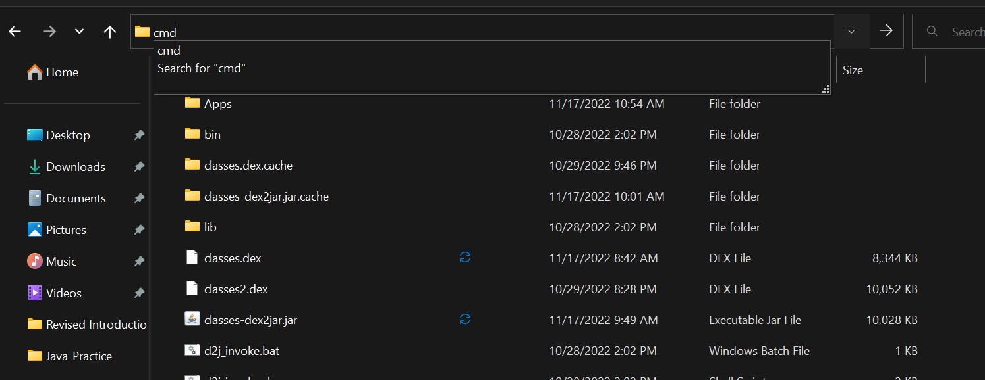

Then fire up this command dex-tools-2.1>d2j-dex2jar.bat classes.dex

This will convert our dex file to readable jar file.

* + 1. To check on the jar file we can use JADX TOOL.

Afer opening the JADX tools the screen will look like this.

* + 1. Click on open file

We need to go to the location where we have extracted jar file using dex-tools and click on the classes-dex2jar.jar file

After opening the jar file the tool will looks like this

Here we can check the source code by clicking on the search option.

When I search for the word zip , I will get all classes which have code involving word ‘zip’ in them.

This is how our search will look like.

Here we can check out the classes we are looking for. We can search with keywords like gip, gzip etc.

To proceed with these steps, you need to install the Testing Tools that are listed

1. **JADX TOOL**

JADX is a Command line and GUI tools for produce Java source code from Android Dex and Apk files.

**Main features: -** decompile Dalvik bytecode to java classes from APK, dex, aar and zip files - decode AndroidManifest.xml and other resources from resources.arsc - deobfuscator included

Link to go through JADX Tool and download:- <https://github.com/skylot/jadx/releases>

1. **Dex2Jar TOOL: -**

The core feature of Dex2Jar is to **convert the classes.** **dex file of an APK to classes.** **jar or vice versa**. So, it is possible to view the source code of an Android application using any Java decompiler, and it is completely readable

The link to download it [https://github.com/pxb1988/dex2jar](https://nam04.safelinks.protection.outlook.com/?url=https%3A%2F%2Fgithub.com%2Fpxb1988%2Fdex2jar&data=05%7C01%7CMeghanaPatibandla%40my.unt.edu%7Ca1c400197cc0416a002e08dabad39a9c%7C70de199207c6480fa318a1afcba03983%7C0%7C0%7C638027715238552767%7CUnknown%7CTWFpbGZsb3d8eyJWIjoiMC4wLjAwMDAiLCJQIjoiV2luMzIiLCJBTiI6Ik1haWwiLCJXVCI6Mn0%3D%7C3000%7C%7C%7C&sdata=v5yDUcY9Ok6SAFQn0fdspnhvCBcOt45PoQdcXQHWyYs%3D&reserved=0)

Here’s a video explaining the above process: - <https://youtu.be/kLJskdY8Ov8>

Here the code for multiple file transfer between server and client.